**ViS0-Nice Reporting Solution**

Thank you for using ViSo-Nice ERD

ViSo-Nice reporting solution is a very simple reporting tool that provides a simple reporting option direct from your database. The purpose is not to replace your commercial reporting solution, but to provide you with a simple alternative for fast reports direct from your data structures.

**Pre-requires**

MS SQL Server (Express will do)

Database to use in the server

**Note:** The reporting server does not work from a flat file structure as the rest of the ERD application. This is because the ERD structure was designed with the purpose of allowing users the place the flat files in one or other source control environment and have some sort of source control over the database files.

**Note:** You can use the same database for all your ERD projects

To use the Report Builder first navigate the **Report Builder -> Setup** and set the connection to the database where the reports data will be stored. The application will create the database and table structure.

**Understanding the Report Builder**

The report builder was developed with developers in mind. As with the ERD, the user interface was developed to provide space rather than beauty, though the aesthetics of beauty was kept in mind, it took the back seat.

**Report Control**

**Note:** The first time you access this screen the program may take some time as it creates the database

**Report Builder -> Reports**

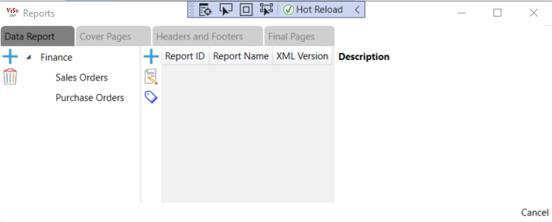

The reports screen is where you add and categorize your reports.

I will briefly explain each tab, and later in more detail the “Data Report” tab.

**Note:** Only the “Data Report” tab allows for report categorization.

On this screen you will find three tabs:

* Data Report
* Cover Page
* Headers and Footers
* Final Page

**Cover Page**

Create cover pages that can be linked to data reports to serve as the cover page when the repot is printed.

**Headers and Footers**

Create headers and footers for data reports that will be printed at the top and bottom of each page of a data report.

**Final Page**

Create a final page to be printed with the repot.

**Note:** For the three mentioned tabs I advise using a naming convention that provides the paper type and size e.g. “A4 Landscape (ViSo-Nice)”. This helps identifying your selections in the report builder.

Each of these types has its own properties that will be explained in the data report.

**Data Report.**

Data reports is where all your reports will be stored. To the left is a report category tree. New categories can be added by selecting the empty space to add a new start of the tree or a specific node to add a child node to the tree.

The reports available in the category will display in the list to the right, for the selected node.

**Note:** Categories are not project specific, but the reports displayed are. This was done with the idea that you may be using one database to report from but different ERD projects. For micro servers this may cause some confusion though.

**Building the Report**

Select the ‘Add new report Content’ button to open the report builder.

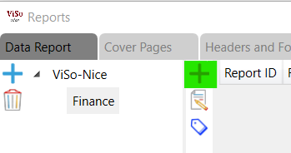

**Note:** You can add Page Headers and Footers, cover pages and final pages at any time after your report was build. Although I have found that developing Page Headers and Footers first helps in the preview to get an better idea of how your final print will look.

**Menu**

* Save – save your current work without closing the window. Note that the “OK” button the right bottom will also save the report but close the window.
* Print Preview – Preview the report. You do not need to save the report before previewing it. Only the first 15 pages are displayed.
* Export to PDF – Exports your report to PDF format on your selected path. This will also open the resulting PDF in your default PDF viewer.

**Report Properties**

* **Name** – The name of the report
* **Description** – A description of your report (VarBinary(Max)), so you can put it in there if you like
* **Report Type** – Displays the type of report (Read Only)
* **Report Version** – The version of the report. You do not need to change the version, only if you are not sure if you would like to have your changes in production.
* **Paper Kind** – This depends on what paper kinds your printer supports
* **Page Orientation**
* **Cover Page** – The first page that will print when the report is printed
* **Page Headers and Footers** – The header and footer that should print on each page of the report, excluding the Cover and Final pages
* **Final Page** – The final page that should be printed with the repot
* **Page Left, Right, Top and Bottom margins** – This is the margins for the printer, and you can change them to fit your printer

**Data Source**

Select the main table and if required related tables that you would like to use in your data report.

**How to build your report**

After setting up you report properties and setup your data source you are ready to start developing your report.

Form the data source tables select and drag your column to the “1- - Data” section. If the selected column belongs to your Main table selected in your data source the column will be added to your canvas, if not another set of canvases will be created to match the table and the column will be placed in the correct canvas.

Columns dropped in data sections will be moved to the correct data section if the column does not belong to the data section it is being dropped in.

**Note:** Report Sections take some understanding.

*Single table reporting - For reports where you are only reporting from one table the Header section will repeat at the top of each page. The data section will print directly after the header on each page filling the page. The footer section will only print after all the data in the data section was printed on the very last page.*

*Reports with multiple tables – For reports where reporting is done from multiple tables the headers and footers may be somewhat confusing and are rather difficult to illustrate but I will try my best in doing so. Foreach section describing a table the header section is printed first and is followed by the data section thereof. After the data section the first header section of the related table is printed. And the sequence is repeated for this section should there be related section under it*

*So, you may end up with two scenarios, and sometimes in one report.*

1. *You have three tables to report from. Both the child tables are directly related from the main table. The report will the print the main header and data sections, then for each related table the header, data, and footer sections before printing the main footer*
2. *You have three tables to report from, the second table relates to the main, and the third to the second. The report will print the main header and data, followed by the second’s header and data, followed by the third’s header, data, and footer, closing the seconds footer, and then the main footer*

*For both these types the process will repeat until all the data rows are printed.*

*You should keep this in mind should you make use of the ‘Report Sum’ toolbox item, as this may get somewhat confusing at times.*

**Data Objects**

Almost all the Toolbox objects are self-explanatory, but the data objects require some explanation. As with most things in life are my ideas not necessarily your expectation, and you may have done it differently, and even better, so feel free to contact me to implement changes, or download the source and you can implement the changes as required.

Meanwhile you would like to use the builders and need to understand what I have done.

**Fields of Importance**

* **Use as Print Parameter** – Setting this value to true will prompt the user for a value when the report is selected for printing. This value must represent a value in the database for the column. Leaving the value empty will ignore the parameter and return all
* **Is Parameter Required** – Setting this value to true will require the user to enter a value when the print action prompts the parameter.
* **Print Parameter Caption** – If this field is empty and the ‘Use as Print Parameter’ is set to True the columns table and name will be used for prompting the user, if not the value specified here will be used. E.g. if empty the user prompt will read ‘YourTable.YourColumn’ if not the ‘Your Custom Name’
* **Print Parameter Default** -You may want to use a filed as filter, but do not want to ask the use for a value, then you fill in this value. E.g. you would like to select only records where the records Active Flag is set to ‘True’, then you would set the ‘Use as Print Parameter’ to true and in this filed type ‘True’ . This will not prompt the user for a value but filter the data to return only records where the database value for the column is true.
* **Use In Order By** – This will use the column in the SQL Order By Clause
* **Is Suppressed** – This will include the column as part of the SQL output query but not print the value on the canvas
* **Suppress if No Data** – This sounds funny, if there is not data nothing will print anyway, but this option ignores the data object and skips the placing of the object on the canvas. This will help where you have an address, and do not what open spaces between the address lines. Note this will not apply within a data row, as this will skew the report, especially if you have labels on in that particular data row’s columns

**Note:** Canvas SQL queries execute separate from one and another. Value such as filters and sorting will only apply to that section, and the data retrieved from the database may impact the subsequent only where the subsequent query makes use of the values in its link setup.

**Replace Column Value With**

This option helps you to present normalized data to an understandable manner to the user.

For this there are two options that can be selected from

1. **From Table**

In this option you may have a value that represents a value or even a set of values in another table. Let us say you have a User_Id column, but the user has a First Name, Second Name, Last Name and Surname. You would like to display all four instead of the User_Id as very view users know whom User 15987 are, but all now ‘Gill de Wet’ (Just the first unknown name and surname that popped into my head, I don’t know such a person, or any reference to such a person, sorry if you carry this name and or surname, ‘John Dow’ seemed a bit morbid)

1. **From Dll**

In some cases, you may have a field that carries a value from an Enum, or even a byte[]. For this you can write your own Dll and place it on a server. The Reporting Solution do not store such Dll’s and will always seek the Dll at this location.

Setting up such a dll has some rules, though

* For this version, the Dll must be of type .Net Framework 4.7.2 or older
* Methods require one input parameter of type string
* Method must return a string value

For byte[] values from the database there are some further requirements

The value retrieved from the database is converted to a string using

System.Convert.ToBase64String(value)

So, the value received in your method must be converted back to a byte[] before you can use it and return it as a string value

byte[] value = System.Convert.FromBase64String(base64String)

**Insert or Update on Print**

It may be so that you would like to keep record of what was printed, e.g. invoice printing. Some counties have laws that requires that an invoice may only be printed once in its original state, there after the invoice a be only printed as a copy or reprint.

For this you can setup the invoice number field to update the Printed flag to ‘COPY’, and then on the report place the Printed Flag field. The printed flag field can then be suppressed and the second time the invoice is printed this flag will show on the report

**Linking Data Sections**

Once you are satisfied with your report on the canvas it is time to link up your tables. Linking report data sections together are important to keep data together in an understandable manner. Select the canvas 3 – Your Table – Data, but not an object in the canvas. The properties window will now display the Canvas properties

In the properties you can now link your data sections together. Keep in mind that the first data section will not display its properties, as linking is done from the bottom up. Though you can link a data section to any other data section above it, you will not be able to link it down wards

Your setup may now look something like this:

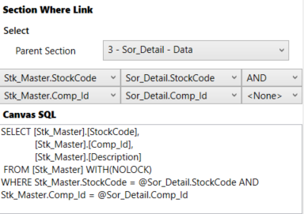

**Note:** The Canvas SQL is only for viewing and you will not be able to change the SQL directly.

**Note:** The SQL can change depending on what column specific setups are performed:

**Note:** To link a data section the linked columns must be available in both Data Section canvases.